2. User-Story Backlog
The university requirements were transformed into simple, generic user stories. Each story was first expressed in a narrative form “As a [user], I want to [do something] so that [result happens],” then organized into the required backlog columns: ID, User, Action, Result / Outcome, and Function. Each story captures one main action and its expected result. The stories focus primarily on user goals and meaningful system behavior. Every story has a unique three-digit ID, and stories belonging to the same feature share the same hundreds digit: 1xx Login, 2xx Register, 3xx Enroll, 4xx Drop, 5xx View, 6xx Change Password, 7xx Admin, and 8xx File I/O. “System” appears in the User column where the action is performed automatically by the application.

2.1. Narrative user stories
1xx — Login
• As a student, I want to log in with my email and password so that I can access the student subsystem.
• As the system, I want to validate the login details so that invalid credentials can be rejected.
2xx — Register
• As a student, I want to register with my name, email and password so that I become a student who can use the system.
• As the system, I want to validate the registration details and assign a unique student ID so that a valid student record can be created.
3xx — Enroll
• As a student, I want to enroll in a subject so that it is added to my enrolment list.
• As the system, I want to create a subject with a unique ID, random mark and grade so that the enrollment information is complete.
• As the system, I want to check the number of enrolled subjects so that a student can’t enroll in more than four subjects.
4xx — Drop
• As a student, I want to drop a subject so that it is removed from my enrolment list.
5xx — View
• As a student, I want to view my enrolment list so that I can see my subjects, marks and grades.
• As an admin, I want to view all registered students so that I can see every student on file.
6xx — Change Password
• As a student, I want to change my password so that my login credentials stay up to date.
• As the system, I want to validate the new password so that only a password meeting the required pattern is accepted.
7xx — Admin
• As an admin, I want to view, organize and categorize all students so that I can monitor their results.
• As an admin, I want to remove a student or clear all records so that I can organized the student data as I see fit.
8xx — File I/O
• As the system, I want to save and load student data so that information persists between sessions.

2.2 Requirements table (backlog)
ID | User | Action | Result / Outcome | Function
1xx — Login
100 | System | log into the application if given valid credentials | Student is taken to the student subsystem | login()
101 | System | match the entered email and password with the ones on file | a registered student is authenticated | match_credentials()
102 | Student | Enter credentials | Credential are entered in the login page | enter_credential()
105 | System | verify the entered email and password against the required patterns | malformed input is rejected before it is checked against the file | validate_credentials()
106 | System | show an error message when the credentials do not match | the student is told the login failed and can retry | show_login_error()
2xx — Register
201 | Student | register by entering a name, an email and a password | a new student account is created | register()
202 | System | validate the email against pre-defined patterns (e.g. emails should end with the domain @university.com) | only valid university emails are accepted | validate_email()
203 | System | validate the password (upper-case start, at least five letters, followed by three or more digits) | only passwords meeting the criteria are accepted | validate_password()
204 | System | generate and assign a unique six-digit student ID (zero-padded, 1–999,999) | each student is uniquely identified | generate_ID()
205 | System | show an error message when the Register details are invalid | the visitor is prompted to re-enter valid details | show_register_error()
3xx — Enroll
301 | Student | request to enroll in a subject | the enrolment request is submitted | enrol_subject()
302 | System | auto-generate a random mark between 25 and 100 for the enrolled subject | the subject is assigned a mark | generate_mark()
303 | System | calculate the subject grade from its mark (Z / P / C / D / HD on the UTS scale) | the subject is assigned a grade | calculate_grade()
304 | System | reject enrolment when the list already holds four subjects | the student is notified the four-subject limit is reached | check_subject_limit()
305 | System | generate a unique three-digit ID for the subject (001-999) | a subject ID between 001 and 999 is assigned | generate_subject_ID()
306 | System | add the generated subject to the student’s enrolment list | the new subject is included in the student’s enrolments | add_subject()
4xx — Drop
401 | Student | remove (drop) a subject from the enrolment list | the selected subject is removed from the list | remove_subject()
5xx — View
501 | Student | view the current enrolment list | all enrolled subjects with their marks and grades are displayed | view_enrolment()
502 | Admin | view all registered students | every student on file is displayed | view_all_students()
6xx — Change Password
601 | Student | enter the new account password | The new password is submitted for validation | enter_password()
602 | System | validate the new password against the required pattern | only a valid new password is accepted | validate_password()
603 | System | Update the student’s password | The valid new password replaces the previous password | update_password()
7xx — Admin
701 | Admin | access the admin subsystem without registering | existing staff can manage students directly | admin_access()
702 | Admin | organize and view students grouped by grade | students are displayed grouped by grade | group_by_grade()
703 | Admin | categorize students into PASS/FAIL by mark (mark < 50 → FAIL; mark ≥ 50 → PASS) | students are classified by outcome | categorise_pass_fail()
704 | Admin | remove an individual student | a single student record is deleted | remove_student()
705 | Admin | clear all student records | the students.data file is emptied | clear_all_students()
8xx — File I/O
801 | System | save registered students and their enrolment details to students.data | student data persists between sessions | save_to_file()
802 | System | load student data from students.data on start-up | the data is available to the student and admin subsystems | load_from_file()

3. UML Use Case Diagram
The two diagrams show the actors, goals and functions of CLIUniApp and GUIUniApp. Actors appear outside the system boundaries. Solid lines connect actors to their available functions. <<include>> arrows point to required supporting actions. <<extend>> arrows point to the main use cases and represent behaviors that occurs under specific conditions. These relationships describe required and conditional behaviors rather than the sequence of user actions.
3.1 CLIUniApp
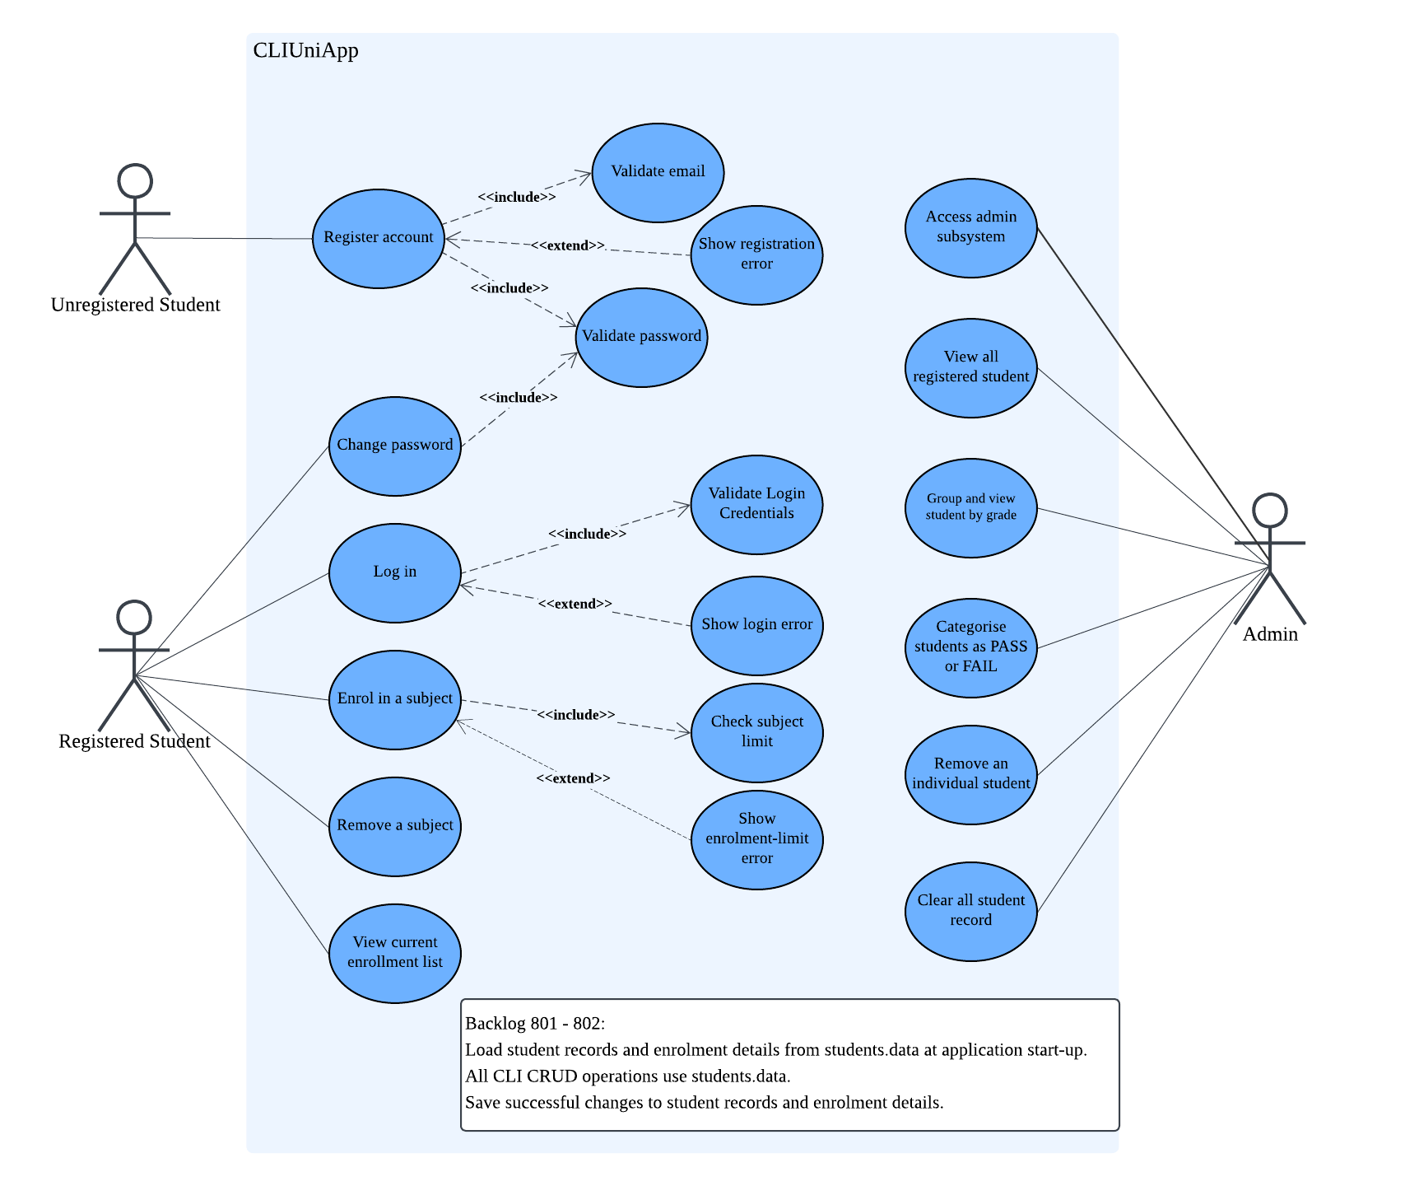
The CLIUniApp diagram identifies three actors: Unregistered Student, Registered Student, and Admin. The Unregistered Student aims to create an account through Register account. The student provides a name, email and password. The system checks the email and password formats through Validate email and Validate password. Both checks have <<include>> relationships with registration. Show registration error extends registration when the details are invalid. Successful registration creates an account with a unique six-digit student ID.
The Registered Student aims to access the student subsystem and manage personal enrolments. During Log in, the system checks input formats and matches credentials with stored records. Validate Login Credentials covers these checks through an <<include>> relationship. Show login error extends login when credentials do not match. Successful login is required before other student operations.
For Enrol in a subject, the system must Check subject limit through an <<include>> relationship. Show enrolment-limit error extends enrolment if the student already has four subjects and requests another. Otherwise, the system adds a subject automatically. Subject ID generation, random mark assignment and grade calculation are internal enrolment steps.
Students use Remove a subject to drop a course and View current enrollment list to inspect subjects, marks and grades. Change password replaces the existing password. It shares Validate password with registration because both operations require the same password checks.
The Admin aims to manage student records through Access admin subsystem. No registration is required. Administrators can view all registered students and group them by grade. They can categories students as PASS or FAIL, which marks below 50 indicate FAIL, while marks of at least 50 indicate PASS. They may delete an individual student or clear all records. Each administrative function is linked directly to Admin. These associations show which management tasks the actor can perform.
3.2 GUIUniApp
GUIUniApp has one actor, Registered Student, whose goals are login and enrolment. Registration and administrative functions are outside its scope. The login window is the main window. Check login fields checks whether the email and password are present. Show empty-field error extends Log in when either field is blank. Successful authentication opens the enrolment window.
During Enrol in a subject, Check subject limit checks whether another subject can be added. A valid request adds a subject to the list. Show enrolment-limit error extends enrolment when a student attempts to exceed four subjects. Both checks have <<include>> relationships with their main use cases. The error messages have <<extend>> relationships because they appear only when the corresponding error conditions occur.
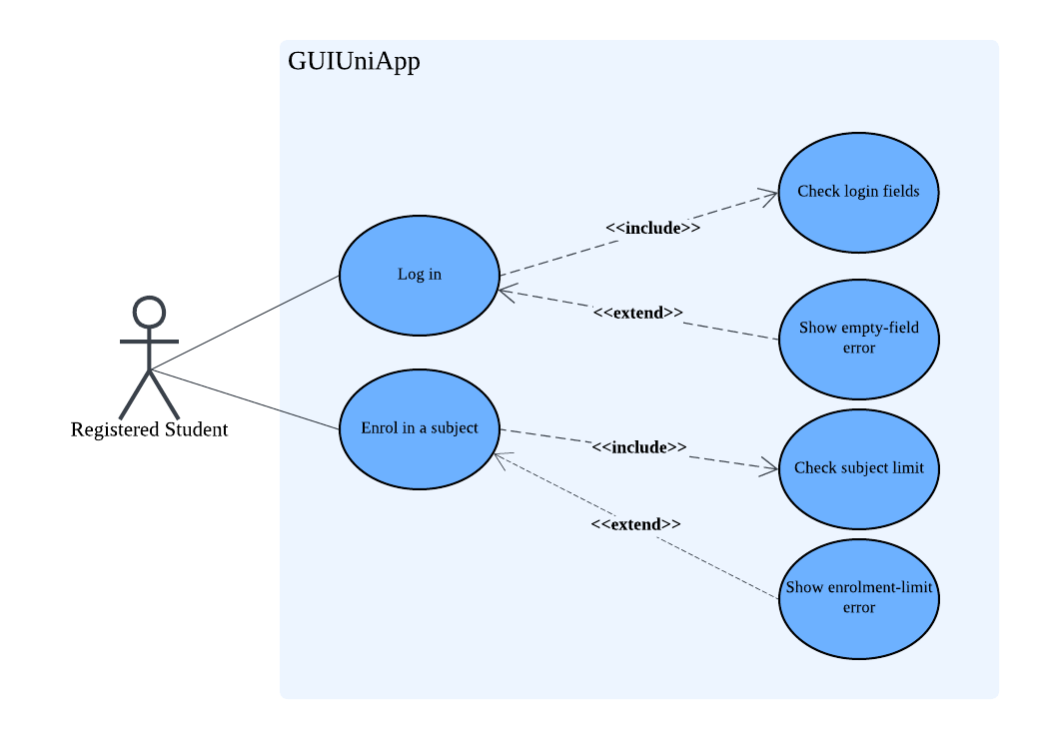
GUIUniApp has one actor, Registered Student, whose goals are login and enrolment. Registration and administrative functions are outside its scope. The login window is the main window. Check login fields checks whether the email and password are present. Show empty-field error extends Log in when either field is blank. Successful authentication will opens the enrolment window.
During Enrol in a subject, Check subject limit checks whether another subject can be added. A valid request adds a subject to the list. Show enrolment-limit error extends enrolment when a student attempts to exceed four subjects. Both checks have <<include>> relationships with their main use cases. The error messages have <<extend>> relationships because they appear only when the corresponding error conditions occur.

